PRO. A DB WITH NAME, DOB

AIM: To implement a prolog program for A DB WITH NAME, DOB.

OBJECTIVES:
To write a Prolog program to create a simple database containing a person's name and date of birth (DOB) and retrieve the DOB of a person using their name.
ALGORITHM:
- Start the program.
- Define database facts containing the name and date of birth of different persons.
- Define a rule to search the database using a person's name.
- Enter the name to be searched.
- Prolog matches the entered name with the database facts.
- If a matching name is found, display the corresponding DOB.
- If no matching name is found, Prolog returns false.
- Stop the program.

SYSTEM-ARCHITECTURE:
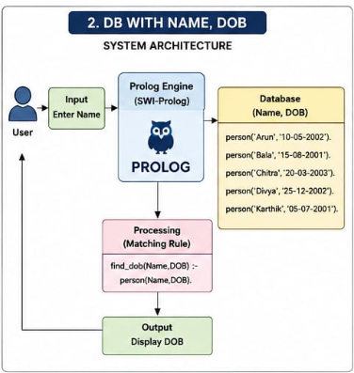

PROGRAM:
% Database containing Name and Date of Birth

person('Arun', '10-05-2002').
person('Bala', '15-08-2001').
person('Chitra', '20-03-2003').
person('Divya', '25-12-2002').
person('Karthik', '05-07-2001').

% Rule to find DOB using Name

find_dob(Name, DOB) :-
person(Name, DOB).

OUTPUT:
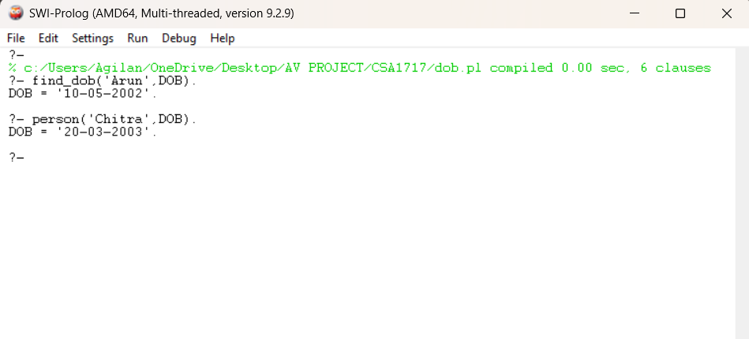

RESULT: Thus the A DB WITH NAME, DOB is implemented successfully using Prolog program.

